D578 APRS-GPS on models that have this option
www.tim-yvonne.com/ham/dmr
Updated Oct 3, 2022

CPS ver 1.16 (radio firmware ver 2.x), software settings for this specific type of use:
DMR memory channel, but wanting to send analog APRS-GPS coordinates
(to appear on the www.APRS.FI website)

At the top of the CPS screen, click on TOOL, then OPTIONS:
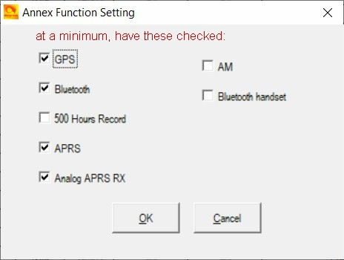

Although your D578 radio knows it has the GPS capability, you also need to tell the CPS software of this.

(multiple pages to these instructions, please scroll down…)

*On the channel screen:

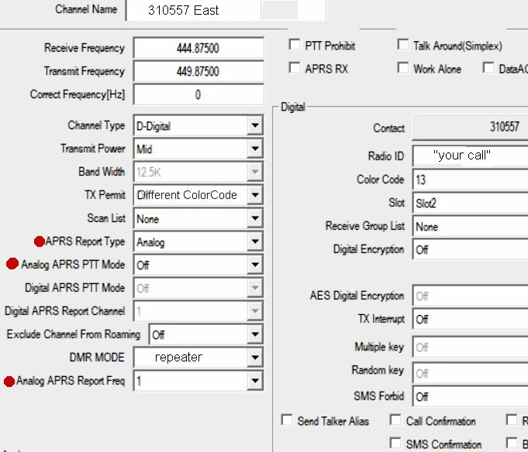

Note, set these fields for every DMR channel you also want your GPS coordinates sent over analog APRS.

You may only want a few channels to have this activated on. For channels you DON’T want GPS APRS auto-
transmitted… set “APRS Report Type” to “Off”; that alone will disable it. The last page of these instructions show how to disable the entire GPS receiver with just one button push.

*Common Setting, Optional Setting, GPS/Ranging tab:

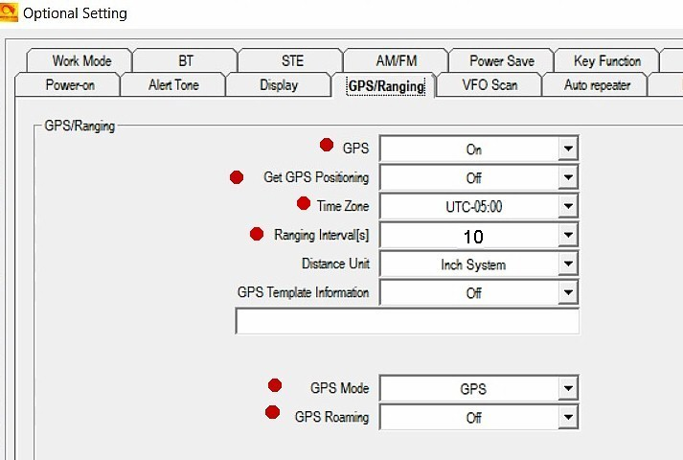

*Common Setting, Optional Setting, APRS tab
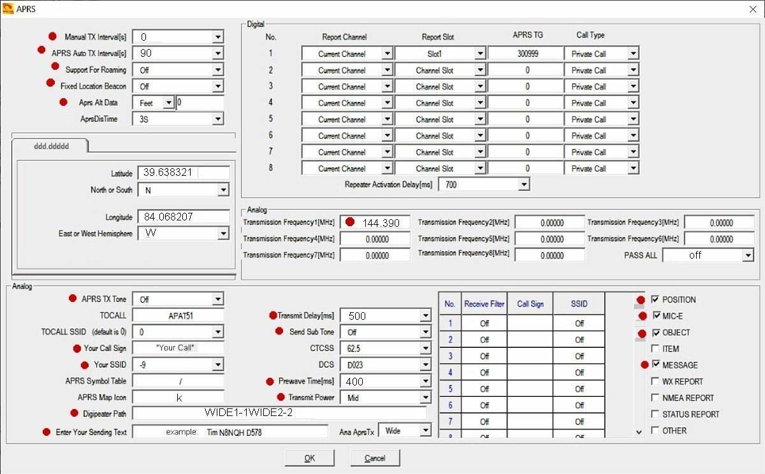

Note: “APRS Auto TX Interval” set to 90 or 120 (seconds)

Note: “Digipeater Path”. Type this exactly as shown, no spaces or commas between anything.

Note: “Enter Your Sending Text” this is like an alias; type in anything you want. Example;
“Monitoring 147.405 simplex” or “Daves D578 mobile” This text is included with your listing on APRS.FI

More pages:
.
.
.
.
.

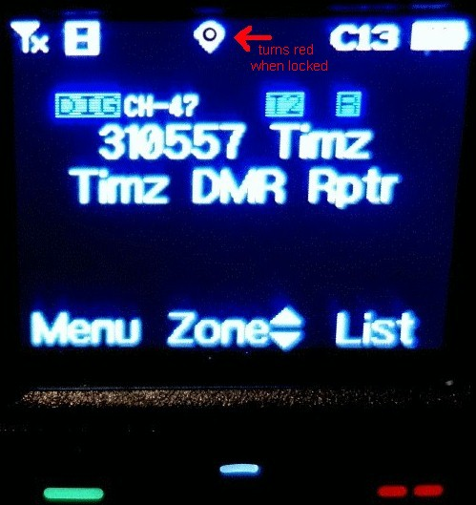

Button Assignment

There are about 5 GPS related functions you can assign to the P-1 through P-6 buttons.

3 of these functions are:

- GPS (this enables/disables the GPS receiver). On my radio, the GPS receiver automatically turns on when the radio is powered up. You can disable the APRS-GPS function (if it’s assigned to the memory channel you are on by simply turning off the GPS receiver
- GPS Information this displays your current coordinates as determined by the GPS receiver
- APRS Send pressing this button will force an immediate GPS coordinate transmission (instead of waiting for the next 90 or 120 second auto-interval).

My suggestion is to assign these three GPS functions to LONG PRESS, and all on the same side of the radio. Easy to remember… all the buttons on that side of the radio are GPS related, all require a long press.

Find the button assignment screen here:
Common Settings – Optional Settings – Key Functions

FAQ
- if receiving a DMR signal, will the APRS-GPS timer interrupt if the timed interval approaches?
  - No, the radio will hold-off until the DMR voice reception is completed.

- If transmitting on DMR and the APRS-GPS timer interval approaches, will it interrupt the transmission?
  - No, the radio will hold-off until you release the PTT, then send the GPS coordinates

www.tim-yvonne.com/ham/dmr

